Boston Housing Price Prediction

Introduction
This document outlines the steps taken to preprocess the Boston Housing dataset, perform correlation analysis, and build and evaluate a regression model to predict housing prices.

Libraries and Data Import
The necessary libraries for data manipulation, plotting, machine learning, and statistical analysis are imported, and the dataset is loaded from a CSV file into a pandas DataFrame.
import numpy as np
import pandas as pd
from pandas.plotting import scatter_matrix
import matplotlib.pyplot as plt
from sklearn.model_selection import train_test_split
from sklearn.linear_model import LinearRegression
from sklearn.metrics import mean_squared_error, r2_score
from sklearn.preprocessing import StandardScaler
import seaborn as sns
from xgboost import XGBRegressor
from scipy import stats

df = pd.read_csv('Boston_Housing.csv')
- numpy and pandas: For data manipulation.
- scatter_matrix, matplotlib.pyplot, and seaborn: For data visualization.
- train_test_split, LinearRegression, and XGBRegressor: For machine learning model training and evaluation.
- StandardScaler: For feature scaling.
- stats: For statistical analysis.

Data Preprocessing
Missing values in specific columns are filled with the median value of each column. Filling missing values ensures that the model does not encounter issues with NaNs during training.
df.CRIM = df.CRIM.fillna(df.CRIM.median())
df.INDUS = df.INDUS.fillna(df.INDUS.median())
df.NOX = df.NOX.fillna(df.NOX.median())
df.RM = df.RM.fillna(df.RM.median())
df.AGE = df.AGE.fillna(df.AGE.median())
df.DIS = df.DIS.fillna(df.DIS.median())
df.RAD = df.RAD.fillna(df.RAD.median())
df.TAX = df.TAX.fillna(df.TAX.median())
df.B = df.B.fillna(df.B.median())
df.LSTAT = df.LSTAT.fillna(df.LSTAT.median())
- This step ensures that missing data does not negatively impact the analysis and model training.

Missing Values Check
Remaining missing values are checked and counted to ensure all NaNs have been handled.
python
Copy code
missing_values = df.isna().sum()
print(missing_values)
- This verifies that no missing values remain in the DataFrame.

Correlation Analysis
The correlation matrix is calculated to understand the relationships between features and the target variable (MEDV). The absolute correlations are sorted and printed.
corr_matrix_medv = df.corr()["MEDV"]
target_corr = np.abs(df.corrwith(df["MEDV"]))
print(target_corr.sort_values(ascending=False))
- Correlation Matrix: Shows how each feature correlates with the target variable.
- Absolute Correlation: Sorting helps identify the most and least influential features.
The correlation matrix is visualized using a heatmap to provide a clear graphical representation of the relationships.
corr_matrix = df.corr()
plt.figure(figsize=(15,10))
sns.heatmap(corr_matrix, cmap="BuPu", annot=True, fmt=".2f", linewidths=0.5, linecolor='gray', cbar=True, cbar_kws={'shrink': 0.8}, square=True)
plt.show()
- Heatmap: Visually represents the correlation matrix, with annotations for clarity.
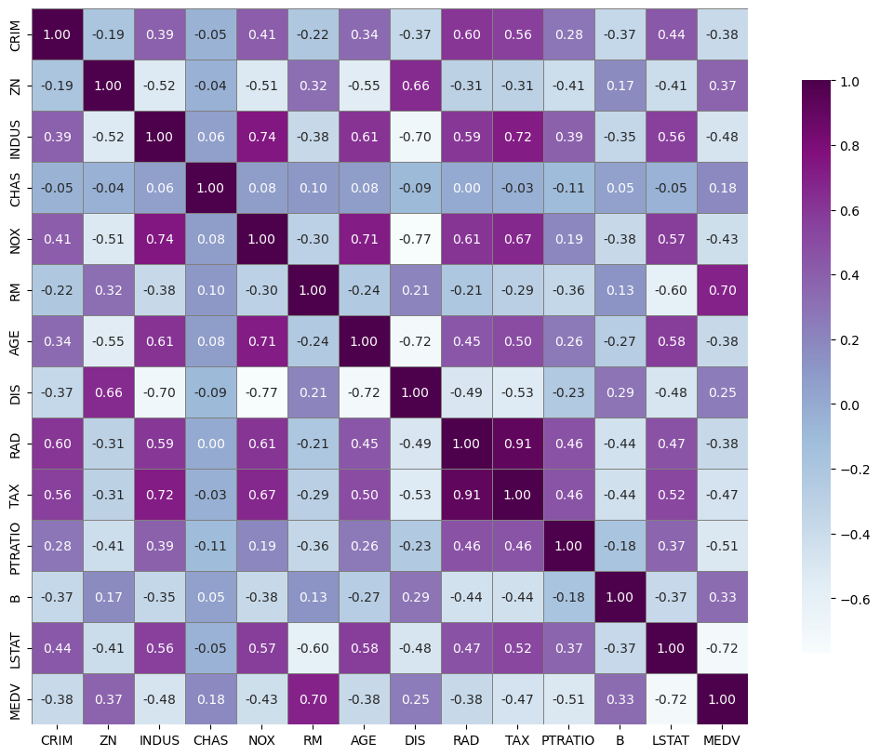

Boxplot Visualization
A boxplot is created for each feature to visualize the distribution and detect potential outliers.
df.boxplot()
plt.show()
- Boxplot: Helps identify outliers and understand the distribution of each feature.
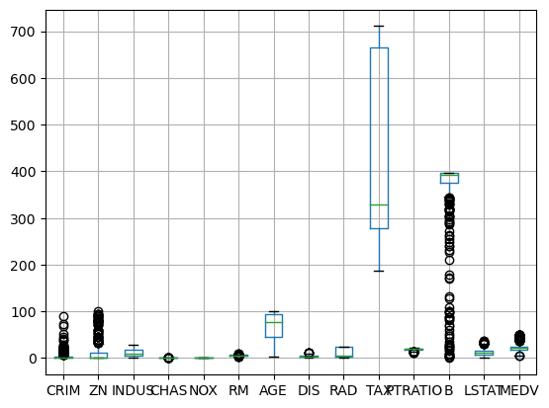

Dropping Unnecessary Columns
Unnecessary columns (CHAS and DIS) are dropped from the DataFrame. This step simplifies the dataset by removing features that may not significantly impact the target variable.
python
Copy code
df.drop(["CHAS", "DIS"], axis=1, inplace=True)
- Dropping Columns: Reduces complexity and potential noise in the dataset.

Data Splitting
The dataset is split into features (X) and the target variable (Y). These are further split into training and testing sets to evaluate the model's performance.
python
Copy code
X = df.drop(['MEDV'], axis=1)
Y = df['MEDV']

X_train, X_test, Y_train, Y_test = train_test_split(X, Y, test_size=0.2, random_state=2)
print(X.shape, X_train.shape, X_test.shape)
- Feature and Target Variable Split: Separates input features from the target variable.
- Train-Test Split: Divides the data into training (80%) and testing (20%) sets for model evaluation.

Model Creation and Training
An XGBRegressor model is created and trained on the training data.
python
Copy code
model = XGBRegressor()
model.fit(X_train, Y_train)
- Model Training: Fits the XGBRegressor model to the training data.

Model Evaluation
The model's performance is evaluated using R-squared and Mean Absolute Error metrics for both training and testing datasets. Actual vs. predicted prices are visualized using a scatter plot.
python
Copy code
tranining_data_prediction = model.predict(X_train)
score_1 = r2_score(Y_train, tranining_data_prediction)
score_2 = mean_absolute_error(Y_train, tranining_data_prediction)
print("R Squared Error:", score_1)
print("Mean Absolute Error:", score_2)

test_data_prediction = model.predict(X_test)
score_3 = r2_score(Y_test, test_data_prediction)
score_4 = mean_absolute_error(Y_test, test_data_prediction)
print("R Squared Error:", score_3)
print("Mean Absolute Error:", score_4)

plt.scatter(Y_train, tranining_data_prediction)
plt.xlabel("Actual Prices")
plt.ylabel("Predicted Price")
plt.title("Actual Prices VS Predicted Price")
plt.show()

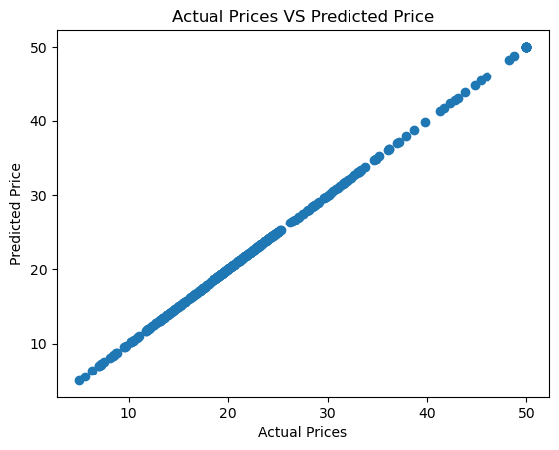
- Training Data Evaluation:
  - R Squared Error: Indicates how well the model fits the training data (higher is better).
  - Mean Absolute Error: Measures the average magnitude of errors in predictions (lower is better).
- Testing Data Evaluation:
  - Similar metrics to assess model performance on unseen data.
- Scatter Plot:
  - Visualizes the relationship between actual and predicted prices for the training set, helping to identify patterns and potential issues.

